Below is a step by step instruction manual to our website. If you have any questions or problems please don’t hesitate to call or email us (08 9295 6688 or bbi@bbimporters.com.au)

Lets get started!

Getting Prices, Availability and Application

To get prices, availability and Applications of parts you have two different options.

Firstly, you can go to the search by Make/Model/Year.

- Click the drop down arrow next to the box with Adly in it.
- Scroll down till you get to your bikes make. So for a KX250 this will be Kawasaki.
- Once you have selected the make click the search button next to this box.
- Next you need to select the model and click search. E.g. KX250.
- The next screen will be the years. LEAVE THIS AS ALL YEARS. Do not select a year! Click search.
- Next you need to select the category. And click search. E.g. Piston Kit or Bearing Crank.
- This will then bring you a page with the part numbers their Application years and the availability.
- On this page you can see recommended retail prices.
- To view trade prices click ‘View Trade Prices’ Blue Link at the top of the table.
- You can then select the next category without going back to the home page. E.g. Gasket Kit Top.

This is the best method is best if you have lots of parts needed for one bike.

Secondly, you can search directly by model and category.

- Go to the catalogue page of our website.
- In the ‘Search By BBI Part Number or Model type in the Model of your bike. E.g. KX250
- This will bring up all the parts that fit THE KX250 in all years. They more common items will be first.
- Alternatively if you type in ‘KX250 Piston’ it will come up with all the pistons available for the KX250’s in all years.

This is the best method for if your searching for multiple different bikes.

Making a Quote/Order

To create a quote or order you must first make sure you are signed in. At the top of the page it will have In white writing your login name,
If it shows Guest you are not logged in properly.

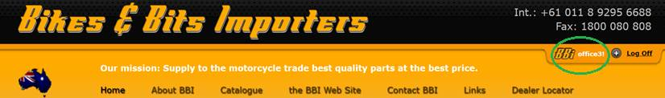

Once you have logged in, click on the Catalogue link at the top of the page. This will take you to the Catalogue Search Page. Once here scroll
down to the bottom of the page and you will see a Create New Quote/Order link. Click it!

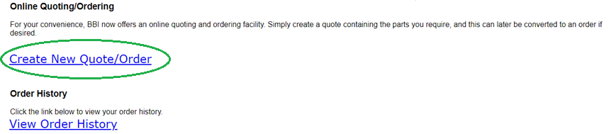

This will take you to page where you put in your shop and bike details. You must put in your business name and a reference for the sale. However,
The bike Make, Model and Year are optional. These are here so that we can check if what you have ordered matches the bike you have. Obviously
If you are ordering for multiple bikes this is not needed. Your Reference can be anything from a purchase order number to the day of the week or
The date.

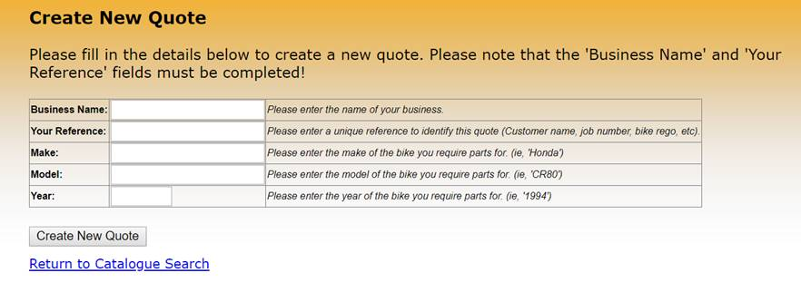

Once you have finished filling out this section clink the Create New Quote button at the bottom of the table. This will take you page that has Quote created
successfully and a link to return to the Catalogue Search Page. Click this Return Link. From here you can use either of the methods stated above to search for
the parts that you need, or if you have the part numbers already you can go straight to these by putting the Part Number in the Search By BBI Part Number.
Once you find the part number you wish to order there will be a small empty box next to it on the left. In this box put how many of this part number you would
like (1,2,10). Then click add to quote at the bottom of the page. Please check the availability of the item and give us a call if its out of stock for an ETA.

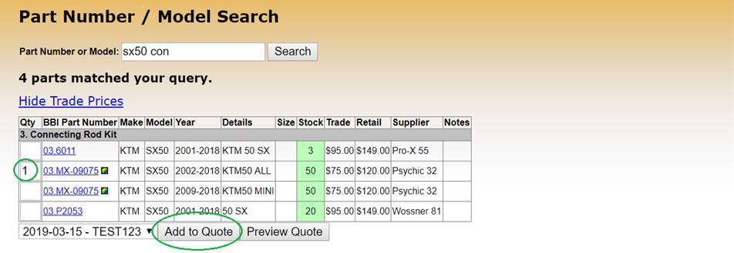

Simply continue to search and add all the parts you need for the order. When you have finished, at the top of the page there will be a View Quote link. Click this.

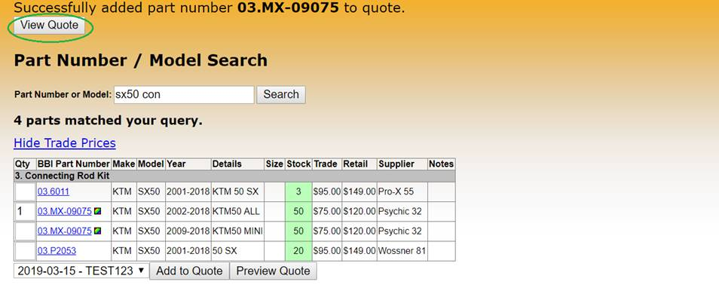

This will take you to a page where you have several options.
- You can update quantities or delete items
To update the quantities just put the new number next to the part number and click update quantities. To delete an item place a 0 next to the part number and click
Update quantities.

- You can print or email the quote
Click the Print or Email Quote link (shown below)

- You can delete the quote
Click the Delete Quote link (shown below)

- You can convert you quote to an order.
Once you are happy with everything and you wish to convert it to an order you can add additional instructions. This could be to back order an item, to put delivery
instructions, to get us to drop ship the parts directly to you customer or Anything in-between. Put the instructions in the box then Click the convert to order link (shown below).

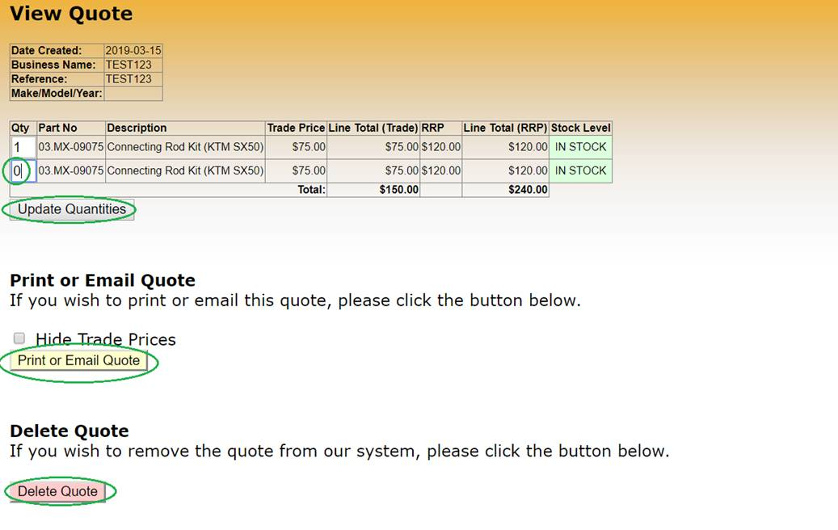
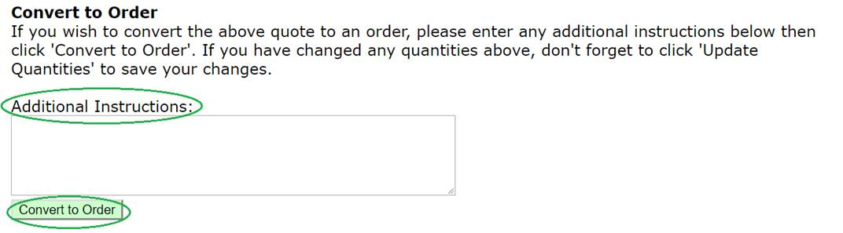

Once you have converted your quote to an order it will be sent through to us. This can take up to 15 minutes for it to show up on our system. As soon as we receive the order we
will process it. If we have any issues with stock quantities, shipping or payment queries or anything else we will call you before sending the items. If everything is fine with the order we will
send it off without contacting you.

I hope this helps you navigate our website. But please, if you have any issues or questions please don’t hesitate to call or email us.

